Business Case Template
Automation & Systems Change Requests
Complete this template when proposing an automation, process, or systems change for review by Controlling & Shared Services.

Submitting team | Finance
Requestor name & role | Carol Muthama – Country Finance Manager (KE)
Entity | Ibero Kenya Limited
Date submitted | 20 July 2026
Systems currently involved | Stock Take Application
Project/ Initiative Name | Optimization of the Stock Take and Reconciliation Application
Document Version | V1.0

How to Use This Template
This template helps you make the case for an automation, process, or systems change. Describe what happens today and be as specific as you can about the impact.

Who this is for
Any team proposing a change that involves automating a manual task, changing how a process works, or introducing/modifying a system or tool.

What happens next
Once submitted, Controlling & Shared Services will review your submission, may follow up with clarifying questions, and will confirm next steps (further scoping, prioritisation, or scheduling).

Tips before you start
- Focus on the problem first: the solution section is easier to write once the problem is clear.
- Use real numbers where you have them (e.g. hours per week, number of people involved) estimates are fine if exact figures aren't available.
- If you're unsure about a section, write what you know and flag what you're unsure of, don't leave it blank.
- Attach any supporting material (screenshots, sample reports, process notes) as an appendix or separate attachment.

1. Scope
Contact | Response
Other stakeholders / teams affected | Warehouse, Logistics, Trade and Quality
Executive Sponsor | Werner Griessel and Yogesh Modhwadia
Business Owner | Werner Griessel and Yogesh Modhwadia

2. The Problem

What isn't working today?
Describe the problem in plain terms. What is frustrating, slow, error-prone, or risky? Who experiences this problem, and how often?
Over the past one year, Ibero Kenya Limited (IBKY) has rebuilt its inventory control into a governed monthly discipline with 57 workshop actions closed, a 17-KPI governance tracker in operation, a Power Apps stock-take application deployed across Ibero and all 3rd-party warehouses, 12 consecutive monthly post-stock-take reviews held and month-end variance reduced from 21,004 bags (February 2026) to 2,824 bags (April 2026). With final positions being circulated at the end-of the month providing limited room for decision making before the next count cycle begins.

The remaining gap is structural and behavioural. Stock is recorded at three different stages in three systems. Physical bags per stack (Power App), lot/outturn in XBS during auction purchase and aggregated primary/secondary baskets in Comtras. Reconciliation between them is performed manually in Excel each month, which is why the count still takes 2–3 days plus 1–2 days of verification in instances when data capture is inaccurate, half a month to triangulate the results and why data-governance issues (unposted entries, duplicates, outturn mismatches) surface only at month-end.

How big is the impact?
Give a sense of scale where you can e.g. hours spent per week, number of people involved, how often errors occur, or any cost/risk this creates. Rough estimates are fine.
Certifying the April 2026 (P04) position took thirty-three calendar days from period end on 30 April to the final report circulation on 2 June against the SOP target of sign-off within seven working days of the count. The count itself was done on the 5th and 6th May, cleanup and physical reconciliation against system by operations team done till 12th May. Once the operations reconciliation was shared with Finance, what followed was a five-hand-off relay of spreadsheets: Operations passed Finance a 2.3 MB physical-vs-XBS Excel recon pack of 15,500 rows on 13 May; Finance rebuilt the position against BRIC stocks and longs and returned a variance report on 19 May. The post-stock-take meeting on 20 May triggered fresh Excel forensics on direct sales, broker stocks and AGL; a further variance-review pack followed on 21 May. The cycle generated at least nine workbooks generated from reviewing 76 worksheets and roughly a million cells; including a 6,700-row AGL variance analysis and an 8,000-row direct-purchase trace manually cross-referenced by Finance and the circulated to around ten staff across Finance, Operations, Trade, Warehouse and Logistics, through three review meetings. This is conservatively 15–20 person-days of analysis per month, on top of counting. The same error families recur each cycle (direct purchases invoiced but not counted, a cancelled contract not amended at BRIC, an unwarranted outturn, longs not physically delivered), so this is a permanent monthly pain point, not a one-off occurrence.
30 Apr
Period end
106,700 bags
across 6 sites
5–6 May
Physical count
16 counters incl. 5 outsourced;
cleanup runs to 12 May
13 May
Ops → Finance
physical-vs-XBS pack:
15,500 rows · 2.3 MB
19 May
Finance → Ops
recon vs BRIC stocks &
longs; variance list generated
2 Jun
Final report
variances not fully traced;
position certified late
21 May
Variance review mtg
new variance packs: AGL 6.7k rows;
8k-row direct-purchase trace
20 May
Post-stock take mtg
Excel deep-dives: direct sales,
brokers, AGL; update sent
Rework loops between 13 May and 21 May: each variance theory = another Excel pack, another meeting, another wait for answers
33 days · 9+ workbooks
period end to final report;
76 sheets · appx 0.9m cells
10 staff engaged in the cycle
3 meetings across six functions

15–20 person-days / cycle
Variance items still open,

Figure 3 : The P04 reconciliation cycle: 33 days, nine workbooks, three meetings, five variance items still open

Why does this matter now?
Is there a specific trigger - growth in volume, an audit finding, a new regulatory requirement, a system change elsewhere? If there's no urgent trigger, that's fine to say too.
The cost is not only the manual effort; it is the delay in decision-making and the increased control risk over a growing inventory book. For five weeks, approximately 106,700 bags, equivalent to around 6,400 tonnes of coffee and representing inventory worth tens of millions of dollars, remained without a certified stock position while hedging, shipment and call-off decisions continued to be made using the best information available at the time. Even when the final reconciliation report was issued on 2 June, significant items remained unresolved that Operations could not fully explain. Every manual reconciliation cycle creates another opportunity for discrepancies to remain hidden in spreadsheets rather than being identified and resolved when they occur.
3. Current Process (As-Is)

Walk us through how this is done today, step by step
List the steps in order, who does each step, and which tools/systems are used (e.g. Excel, email, Sun Systems, paper forms). Include roughly how long the whole process takes.
A process audit and cross-functional workshop (July–August 2025) defined the problem in our stock take process and produced 57 corrective actions which were all closed.
- An Inventory Governance and Performance Tracker (September 2025) institutionalized monthly reconciliation of physical stock against XBS and BRIC/Comtras monitored using 17 KPIs.
- A Power Apps stock-take application (December 2025) digitized counting; every count since is captured end-to-end, time-stamped and tied to counter identity.
- Counting capability has scaled: day-one coverage rose from approximately 16,700 bags (January 2026) to 53,454 bags with 9 counters (March) and 71,251 bags with 16 counters (April) - 67% of the 106,700-bag universe in a single day.
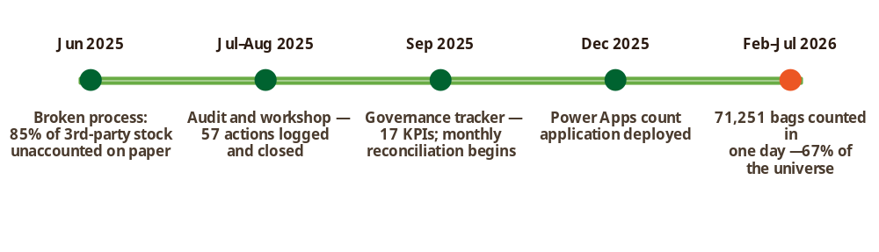
Figure 1: The journey: June 2025 - July 2026.
21,004
Feb 2026
12,077
Mar 2026
2,824
Apr 2026
-Time consuming recon in three cycles
Bags to reconcile at count close
Figure 2: Month end variance to reconcile (bags, physical vs BRIC)

What workarounds or manual effort are currently required?
e.g. manual copy-pasting between systems, double data entry, checking things by phone/email, re-work due to errors.
- Manual triangulation across systems. Physical counts (bags per outturn per stack), XBS (lot/outturn, two profiles) and Comtras (basket level) are reconciled by hand in spreadsheets every month.
- Discovery at month-end. Unposted GRNs, duplicate entries, off-system long positions and outturns/system mismatches (e.g. outturn 23KC2001 on system vs 23KP2001 on the bag) are found during the count instead of on the day they occur.
- Count duration and cost. The count runs 2–3 days plus 1–2 days of re-verification, with documented late starts, device downtime and overtime. The March AGL 3rd party count ran to 9PM.
- Third-party friction. Co-mingled stock at AGL's four sites, part lots split across locations, and dependence on AGL staff for stock identification slow the exercise and generate avoidable variances.

IBKY’s inventory position is fragmented across three systems at three levels of detail, connected only by manual monthly effort. This caps count speed, delays financial certainty, and leaves the control environment dependent on individual diligence rather than systems.
PHYSICAL — Power App
Bags and pockets per outturn,
per stack and warehouse
XBS — lot / outturn
IBERO KENYA profile (auction,
warrants) + BRIC KENYA profile
COMTRAS — baskets
3 primary baskets · 57 secondary
quality codes ·
Master mapping established at purchase: Outturn No. → Quality Code (PB) → secondary basket → primary basket (contract) · 537 sales net off at the primary basket
Figure 3: One coffee, three grains: the reconciliation gap and the translation spine that closes it
The connection between the various data sets already exists in IBKY’s own data. Every auction lot is uploaded to XBS with its Outturn No. and Quality Code (PB) which is precisely its Comtras secondary-basket allocation, rolling up to the primary basket (contract). When BRIC sells, the 537 report relieves inventory against that same primary basket and sales contract. Fixing this mapping once, at purchase, and rolling every movement (STI, GRN, shipping instruction, gate-out, 537 sale) forward daily produces a continuously reconciled position. The monthly count then becomes a one-day confirmation of a position already proven weekly

4. Proposed Solution (To-Be)

What are you proposing?
Describe the change in plain language, this could be automating a step, introducing a new tool, changing a workflow, or something else. You don't need to know the technical details; describe the outcome you want. You can add a link to the solution or any additional reference material.
PHASE 1
Build the reconciliation foundation —
Power Platform · daily exceptions
PHASE 2
Provide operational visibility -Power BI dashboards. Weekly stock forecasts
· KPI monitoring
PHASE 3
Intelligent inventory management. AI assisted reconciliation —
real-time count-day matching
Figure 4: Delivery roadmap: nine months from discovery to the AI-assisted one-day count

Phase 1 - Build the Reconciliation Foundation

Enhance, do not replace: Pathways builds on the stock tool IBKY already runs. The scope opens with a comprehensive audit of the current Power Apps stock-take application and a detailed optimization roadmap aligned to the objectives in this case, which then governs the Phase 1–3 build.
- Establish a master inventory mapping linking each Outturn Number to its corresponding Quality Code, secondary basket and primary basket, creating a single reference point for reconciliation across all systems.
- Automate daily tracking of XBS movements (purchases, warrant mapping, STI, GRN, SI, stuffed out) and Comtras positions using Power Automate/dataflows into a governed data warehouse.
- Compute the rolling mass balance per location and outturn: opening + purchases − shipments − 537 sales ± transfers = expected position, so each period opens exactly where the prior period closed; flag exceptions (unmapped warrants, unposted GRNs, blank-field STIs, sales relieved against the wrong basket) on the day they occur. The mass balance output is at both BRIC level and XBS level.

Phase 2 - Visibility: Power BI for Operations and Finance
- Weekly forecasted stock position by warehouse and outturn, with basket roll-up for Finance — the reference for weekly physical spot-confirmations at Ibero and third-party sites. Stockade loss managers to validate the weekly close position reported at AGL.
- Variance and exception dashboard: open tickets, ageing, root-cause categories, third-party stock levels against the ≤6,000-bags location count-day ceiling.
- Automated KPI scoreboard for the inventory governance KPIs for discussion during the Monthly post-stock take review

Phase 2 detail - the Power BI dashboard suite
Six dashboards, one data model. All read from the Phase 1 data warehouse store at outturn level and roll up to warehouse, third-party site and Comtras basket, so every number ties back to the same spine.

Dashboard | Audience & cadence | What it shows
1. Weekly Forecast Stock Position | Operations & Finance; refreshed daily, issued Friday | Expected position per warehouse and outturn from the rolling mass balance (opening + purchases − shipments − 537 sales ± transfers); movement waterfall for the week; drill-down network → warehouse → stack → outturn; basket roll-up view for Finance; variance vs the last confirmed physical position
2. Three-Way Reconciliation | Finance Stock Control, CFM and Operations; weekly and at count close | Physical vs XBS vs Comtras matched at outturn and rolled to primary/secondary basket, net of 537 sales relief by primary basket and sales contract; matched vs unmatched lines; gross and net variance in bags and value; gauge against the ≤0.10% target
3. Exception & Variance Ticketing | Stock Control Officer, process owners; live | Day-of-event exceptions (unmapped warrants at EOD, unposted GRNs, blank-field STIs, tag/system mismatches); open variance tickets by root cause (duplicate entry, unposted delivery, mapping error, part lot), owner and ageing against the 5-working-day closure SLA
4. Count-Day Live Operations | Stock take Lead, Warehouse Manager; real time on count day | Live coverage % by zone and site; bags counted per counter per hour vs the 6,000–7,000/day benchmark; recount queue; variances flagged as submissions land — the screen that makes the one-day count manageable
5. Third-Party Stock & Ageing | Operations Lead, Logistics; weekly | Stock per third-party location against the ≤6,000 bags/site count-day ceiling); ageing with >21-day call-off alerts; AGL four-site detail; part-lot register showing lots split across locations before the count
6. Governance KPI Scoreboard (SOP §10) | CFM, Monthly Operations Review; monthly with trends | Same-day posting rates (purchase upload, GRN, gate-out); warrant mapping by T+1; blind-count coverage; net variance trend; reconciliation sign-off days vs the ≤7-day target; corrective-action closure vs ≥90% — replacing the manually compiled governance tracker

Design principles: one certified data model (no departmental copies); every visual drillable to the outturn line behind it; row-level security by role; alerts pushed via Teams/Outlook rather than waiting to be opened; and each dashboard retires a manual spreadsheet rather than adding to the pack.

Phase 3 - Data warehouse and AI-assisted reconciliation
- Establish the data warehouse consolidating XBS, Comtras and Power Apps count history as the single analytical source.
- AI-driven count-day reconciliation: each counter submission matched to XBS and Comtras per outturn in near real time, variances flagged to supervisors before counters leave site, and causes auto-classified (duplicate entry, unposted delivery, mapping error, part lot).
Predictive insights: variance-risk scoring by location and lot, counter productivity analytics, and stock-ageing alerts driving the >21-day third-party call-off rule.

What would be different day-to-day?
Describe how the process would work once the change is made. What steps would be removed, simplified, or automated?

Benefit | Today | Target state
Stock-take elapsed time | 2–3 count days + 1–2 verification days | 1 day, confirmation-only
Counter effort per cycle | Up to 16 counters across 3 days in multiple locations plus overtime | ≤15 counters × 1 day (≤15 counter-days); overtime eliminated
Reconciliation close | 15-20 days after count | Same week; Sign-off well inside the 7-day SOP target
Variance discovery | At month-end (Feb peak: 21,004 bags to reconcile) | Day-of-event exception alerts; month-end variance sustained near the ≤0.10% target
Outsourced count support | 5 external counters + supervisors per cycle | Reduced scope as weekly confirmation shrinks count-day workload

- Business Certainty: A trusted weekly stock position for working-capital, hedging and shipment planning — not a monthly snapshot.
- Audit readiness: Full lot-to-basket traceability with a time-stamped audit trail, directly answering any external observer's count findings.
- Scalability: Volumes have grown and will grow; the platform absorbs growth without proportional growth in counting and reconciliation effort.
- Control resilience: The process stops depending on individual heroics; SOP controls become system enforced.

Have you considered any alternatives?
If you looked at more than one way to solve this, briefly note the other option(s) and why you're proposing this approach. If not, you can leave this blank.

N/A

5. Software Development & Delivery (Filled by Third Party Developer)
Complete this section for any change involving custom development, integration, or configuration by an internal or external development team.

5.1 Development Approach
Delivery methodology, technology stack, environments (Dev / Test / UAT /Prod), source control, testing strategy, security and data-protection approach.
Delivery methodology | Pathways will apply a hybrid Agile delivery methodology, combining structured upfront discovery and solution design with iterative sprint-based build, validation and refinement. The engagement will begin with confirmation of business requirements, current-state process review, source-system assessment and solution architecture. The build will then proceed through short delivery sprints covering Power Apps enhancement, dataflows, reconciliation logic, exception management, AI-assisted reconciliation and copilot agent configuration and Power BI dashboards. Each sprint will include backlog prioritisation, configuration, internal testing, client review, issue resolution and agreed sign-off checkpoints.  Pathways will incorporate Microsoft Copilot Studio as the AI-assisted reconciliation layer within the proposed solution architecture. The Copilot Studio agent will support stock control, finance and operations users by helping interpret reconciliation exceptions, classify likely root causes, suggest next-best actions, and guide users through the resolution workflow.  The agent will not replace business approval, finance sign-off or stock control judgment. Its role will be advisory and workflow supportive. Final reconciliation decisions, exception closure, variance approval and stock position sign-off will remain the responsibility of IBKY’s authorised business users.  - The Copilot Studio agent will operate within defined boundaries, including:  assisting users to understand open reconciliation exceptions;  - classifying likely root causes such as duplicate entry, unposted GRN, outturn mismatch, mapping error, part lot or wrong basket relief;  - guiding users on the next step required to resolve an exception;  - retrieving approved information from the reconciliation data model, exception register and dashboard layer;  - supporting preparation of reconciliation review summaries;  - escalating users to the relevant owner or department where an issue exceeds SLA.
Technology stack | The proposed solution will be implemented primarily on the Microsoft Power Platform and Microsoft data ecosystem.  - Power Apps will be used to enhance the existing stock-take application and support exception capture.  - Power Automate and/or dataflows will support workflow automation, alerts and data movement.  - Power BI will provide the reporting and dashboard layer for Operations, Finance and Inventory Governance.  - The reconciliation data store will be implemented using an agreed Microsoft-based data layer such as Dataverse, SharePoint, SQL, Microsoft Fabric or Azure, subject to IBKY’s existing environment, licensing and technical readiness.  - Teams and Outlook will be used for notifications, alerts and action tracking where applicable.  - Microsoft Copilot Studio will be used to configure the AI-assisted reconciliation agent, subject to IBKY/HQ technology approval, licensing and environment readiness.
Environments | Pathways recommends a controlled environment structure comprising Development, User Acceptance Testing and Production. The Development environment will be used for solution configuration and internal testing. The UAT environment will be used by IBKY business users to validate app enhancements, reconciliation outputs, exception workflows and dashboards before release. The Production environment will host approved components following sign-off. Where IBKY’s Power Platform setup allows, environment separation, role-based access and deployment controls will be configured to reduce operational risk and protect production stability.  Prior to configuring the Copilot Studio agent, Pathways will work with IBKY and the relevant HQ technology team to confirm the appropriate developer account, environment, licensing, security model, authentication approach and deployment approvals. The Copilot Studio agent will be developed and tested in an approved non-production environment before being promoted to production following IBKY sign-off.
Source control & CI/CD | Solution components will be managed through a structured release and version-control approach. Power Platform components will be packaged and moved across environments using appropriate solution management practices. Power BI files, data model artefacts, dataflow specifications, configuration documents, mapping tables, release notes and technical documentation will be versioned and stored in an agreed project repository. Where available and appropriate, Azure DevOps, GitHub or an approved Microsoft 365 repository will be used to manage version history, deployment records, issue tracking, release approvals and change-control evidence.
Testing strategy | Pathways will apply a layered testing approach to ensure that the solution is technically sound and operationally fit for use. Testing will include unit testing of Power Apps screens, validation rules and Power Automate flows; system integration testing for Power Apps, XBS, Comtras/BRIC and stock-take data ingestion; reconciliation testing for the master inventory mapping and rolling mass balance logic; dashboard validation for KPI calculations, filters, drill-downs and role-based access; and UAT with IBKY Operations, Finance, Stock Control and Warehouse users. Testing will also include validation of the digital reconciliation workflow, electronic sign-off process, SLA timers, exception escalation rules and Copilot Studio agent responses. AI-assisted outputs will be tested against agreed exception scenarios to confirm that the agent provides relevant advisory guidance, correctly classifies common root-cause categories and clearly routes final review and approval to authorised human users.  Regression testing will be conducted before production release, and count-day performance will be assessed to confirm that the solution can support the required operational usage.
Security & data protection | The solution will be designed with role-based access, least-privilege permissions and appropriate segregation of duties across Operations, Finance, Stock Control, Warehouse teams and administrators. Access to dashboards, mapping tables, exception registers and app functions will be controlled by role, warehouse/site and business responsibility where applicable. Microsoft platform security controls will be leveraged for authentication, encryption in transit and at rest, audit logging and access governance. The solution will also consider data protection obligations relating to user identity, counter activity, warehouse records, operational logs and any business data processed through the reconciliation layer. Any sensitive or restricted data access will be subject to IBKY approval and agreed governance controls.  The Copilot Studio agent will be configured within agreed access, data protection and governance boundaries. The agent will only access approved data sources and will not perform autonomous approvals, source-system postings, financial adjustments or inventory corrections. Its outputs will be advisory, auditable and subject to human review. IBKY/HQ technology approval will be required for any agent licensing, developer account setup, environment configuration and production deployment.
Support model post go-live | Following go-live, Pathways will provide a defined hypercare period to support stabilization, issue resolution, user guidance, dashboard validation and reconciliation monitoring. Hypercare is expected to run for two to four weeks, depending on the agreed deployment scope. During hypercare, Pathways will support monitoring of data refreshes, exception escalation behaviour, digital reconciliation workflow performance, Copilot Studio agent responses, dashboard accuracy and user adoption. After hypercare, day-to-day ownership will transition to IBKY’s nominated business owners, Stock Control, Finance and IT teams. Pathways may continue to provide support under an agreed support retainer, SLA or change-request arrangement covering defect resolution, minor enhancements, reconciliation logic updates, dashboard refinements, exception rule updates, escalation rule changes, Copilot Studio agent refinement, user support and ongoing optimisation.

5.2 Expected Output / Deliverables
# | Deliverable | Description | Acceptance Criteria
1 | Solution design document | A comprehensive design document setting out the proposed stock-take optimisation, inventory reconciliation and visibility solution. The document will cover the current-state findings, target operating model, functional requirements, master inventory mapping approach, reconciliation logic, exception management workflow, dashboard requirements, user roles, security model, implementation assumptions and phased delivery plan. | Document submitted and reviewed with IBKY stakeholders; business requirements and scope boundaries clearly documented; master mapping and reconciliation approach described; key assumptions, dependencies and exclusions included; IBKY provides written approval or consolidated comments within the agreed review period.
2 | System architecture diagram | A visual and technical architecture showing how the existing Power Apps stock-take application, XBS, Comtras/BRIC, dataflows/Power Automate, data warehouse, exception register and Power BI dashboards will connect. The diagram will show source systems, data ingestion routes, staging/data warehouse layer, master mapping table, reconciliation engine, dashboard layer, user access and alerting channels. | Architecture reviewed with IBKY IT, Operations and Finance; all key source systems and data flows represented; integration assumptions and data access methods documented; security and access layers shown; architecture approved as the baseline for build and configuration.
3 | Configured / developed solution | Enhancement of the existing Power Apps stock-take solution and configuration of the supporting reconciliation components. This may include improved validation rules, mandatory fields, controlled dropdowns, duplicate warnings, supervisor review, count-day exception capture, counter identity tracking, location/outturn controls, exception register and the supporting master mapping/reconciliation tables. | Configured solution materially aligns with the approved solution design; agreed Power Apps enhancements implemented; master mapping and exception components configured; key user roles and permissions applied; solution demonstrated to IBKY; critical/high defects resolved or formally accepted for later remediation.
4 | Integration / interface build | Configuration of data ingestion and interface processes to bring together Power Apps stock-count data, XBS movement data and Comtras/BRIC position data into the agreed data store or staging layer. This includes source-to-target mapping, dataflow or extract setup, movement-type mapping, validation rules, rolling mass balance logic and exception flagging. | Agreed source data loads into the target data layer; Power Apps, XBS and Comtras/BRIC data fields mapped according to approved source-to-target mapping; sample records reconcile through the master mapping; rolling mass balance produces expected position output; exception rules generate expected flags during test scenarios; any unavailable source-system dependency documented.
5 | Test evidence (System Integration Testing / User Acceptance Testing) | Test artefacts demonstrating that the solution has been tested technically and validated by business users. This will include SIT test scripts, UAT scripts, test scenarios, reconciliation test cases, dashboard validation checks, defect logs, retest evidence and user sign-off records. Testing will cover data ingestion, mapping, mass balance, exception generation, dashboard outputs, role-based access and app enhancements. | SIT completed by Pathways with evidence of test results; UAT conducted with nominated IBKY users from Operations, Finance, Stock Control and IT; critical and high-priority defects resolved or formally deferred; reconciliation outputs validated against agreed sample data; UAT sign-off received or deemed accepted in line with the agreed acceptance process.
6 | User & admin documentation | Documentation to support business users, administrators and support teams after deployment. This will include user guides for the enhanced stock-take app, exception register and Power BI dashboards; admin configuration notes; data refresh and reconciliation runbook; mapping maintenance guide; dashboard guide; access management notes; and troubleshooting guidance. | Documentation submitted in editable or agreed format; user and admin guides cover the deployed solution components; data refresh, exception handling and mapping maintenance steps documented; IBKY admin users can follow the documentation during handover; documentation reviewed and accepted by the nominated IBKY owner.
7 | Training / handover materials | Training and handover materials for IBKY users, supervisors, stock control, Finance, Operations and administrators. Materials will cover stock-take app enhancements, exception capture and resolution, dashboard interpretation, weekly reconciliation process, master mapping maintenance, user roles, support process and post-go-live operating rhythm. | Training materials prepared and delivered to agreed user groups; attendance records captured; handover session conducted with IBKY business and technical owners; key operating procedures explained; open issues and support process documented; IBKY confirms readiness to use and administer the solution after go-live/hypercare.
8 | Copilot Studio AI-assisted reconciliation agent | Configuration of a Microsoft Copilot Studio agent to support AI-assisted reconciliation. The agent will help users interpret exceptions, classify likely root causes, suggest next-best actions, support exception review, and guide users through approved reconciliation workflows. The agent will operate within agreed security, licensing, data access and human-review boundaries. | Copilot Studio agent configured in the approved environment; agent use cases and boundaries documented; HQ/IBKY technology team engaged on licensing and developer account setup; agent tested against agreed exception scenarios; outputs clearly marked as advisory; human review workflow documented; IBKY confirms the agent is fit for MVP use.
9 | Digital reconciliation workflow with electronic sign-off | A fully electronic stock reconciliation workflow that enables stock control, finance, operations and relevant approvers to review, validate, resolve exceptions and digitally sign off the reconciliation within the agreed SOP timeline. The workflow will support owner assignment, review status, sign-off evidence, timestamps, audit trail and completion tracking. | Workflow configured and tested; reconciliation records can be submitted, reviewed and digitally signed off by authorised users; sign-off timestamps and approver identity are captured; workflow supports the agreed target of reconciliation completion within less than 7 days post stock take; audit trail is available; UAT sign-off received from IBKY Stock Control and Finance
 | Exception escalation workflow | Extension of the exception register to include SLA-driven escalation. Exceptions will be assigned to owners and monitored against agreed timelines. If an issue is not resolved within the required timeframe, the system will alert the owner and escalate to the next level in the departmental chain until closure. | Exception register includes owner, department, due date, SLA status, escalation level, ageing, root cause and closure status; overdue exceptions trigger alerts; escalation hierarchy is configured and tested for agreed scenarios; Dashboard: Exception & Variance Ticketing reflects open exceptions, ageing, overdue items and escalation status; IBKY validates escalation rules during UAT
 | Exception monitoring and data-quality ROI report | A reporting component that tracks reconciliation exceptions, root causes, owners, ageing, recurring issues, SLA breaches and resolution performance. This becomes a key management tool for improving data quality and building confidence in the accuracy of the reported stock position. | Exception report/dashboard shows open, closed, overdue and escalated exceptions; root-cause categories are visible; owner and department performance can be tracked; recurring data-quality issues are identifiable; report supports monthly governance review and ROI tracking; IBKY confirms that the report supports adoption and control monitoring objectives.

5.3 Expected Timelines
Indicative phase plan — refine during scoping with Shared Services and the development partner.
Phase | Key Activities | Owner | Start | End | Duration
Discovery & requirements | - Conduct project kickoff and stakeholder alignment  - Review current stock-take process and manual reconciliation workflow  - Audit the existing Power Apps stock-take application  - Review XBS, Comtras/BRIC and Power App source data availability  - Confirm dashboard users, governance KPIs, reconciliation pain points and reporting requirements  - Confirm system access, data access, UAT users and business dependencies | Pathways PMO / Business Analyst, with IBKY Operations, Finance, Stock Control and IT | 01/09/2026 | 11/09/2026 | 1-2 Weeks
Design & architecture sign-off | - Define target solution design and implementation approach  - Design master inventory mapping structure  - Define source-to-target mapping for Power Apps, XBS and Comtras/BRIC data.  - Define rolling mass balance logic and exception rules.  - Design Power BI dashboard suite and certified data model.  - Define security, row-level access and alerting approach.  - Review and sign off solution design and architecture baseline. | Pathways Solution Architect / Data Architect, with IBKY IT, Finance and Operations | 07/09/2026 | 18/09/2026 | 2 Weeks
Build / configuration | - Enhance the existing stock-take Power App.  - Configure master inventory mapping table.  - Build Power Apps, XBS and Comtras/BRIC data ingestion/dataflows using approved extracts and upload templates where APIs are not yet available.  - Configure rolling mass balance logic at XBS and BRIC levels.  - Configure exception register and variance ticketing workflow.  - Configure SLA rules for exception ownership, ageing and escalation.  - Configure time-based alerts and escalation through Teams/Outlook where applicable.  - Configure the digital reconciliation workflow, including electronic review, approval and sign-off.  - Configure Copilot Studio AI-assisted reconciliation agent for exception classification, user guidance and next-best-action support.  - Build priority Power BI dashboards and KPI scoreboard components.  - Update Exception & Variance Ticketing dashboard to include exception ageing, overdue items, escalation status, owner performance and root-cause trends. | Pathways Power Platform Lead, Data Engineer and BI Developer | 14/09/2026 | 09/10/2026 | 4 Weeks
SIT (System Integration Testing) | - Test data ingestion across Power Apps, XBS and Comtras/BRIC  - Validate source-to-target mapping and master inventory mapping  - Test rolling mass balance calculations  - Test exception generation and ticket ageing rules  - Test dashboard refresh, filters, drill-downs and KPI calculations  - Test role-based access and security configuration  - Resolve technical defects before UAT | Pathways QA Lead / Technical Team, with IBKY IT and data owners | 05/10/2026 | 16/10/2026 | 2 weeks
UAT (User Acceptance Testing) | - Conduct UAT with Operations, Finance, Stock Control and Warehouse users  - Validate stock position, reconciliation outputs and dashboard figures  - Test exception tickets, root-cause categories and ageing  - Validate count-day workflows and supervisor review process  - Log, prioritize and resolve critical/high defects  - Obtain business sign-off or agreed defect deferrals. | IBKY Business Owners / UAT Leads, supported by Pathways QA and Delivery Team | 12/10/2026 | 23/10/2026 | 2 Weeks
Cutover & go-live | - Conduct production readiness review  - Migrate approved components to production  - Confirm user access and security groups  - Validate data refresh schedules and dashboard publishing  - Activate alerts and exception notifications  - Communicate go-live and monitor first production use | Pathways PMO / Technical Lead, with IBKY IT and Business Owners | 22/10/2026 | 27/10/2026 | 4 Business Days
Hypercare & handover | Provide post-go-live support and issue resolution.  Monitor data refresh, dashboards, exception workflow and app usage.  Support users during first operational cycle.  Conduct admin and business handover sessions.  Submit user guides, admin documentation, runbooks and open issue log.  Submit Phase 2/3 optimisation roadmap | Pathways Support Lead / PMO, with IBKY IT, Stock Control, Finance and Operations | 28/10/2026 | 10/11/2026 | 2weeks

The above dates are indicative and will be refined during the detailed scoping and mobilisation phase. The proposed schedule assumes timely access to the existing Power Apps stock-take application, XBS and Comtras/BRIC data extracts, IBKY subject matter experts, UAT users, Microsoft environment access and business sign-off at each phase gate. Major delays in data access, system access, licensing, source-system availability or business validation may affect the timeline and will be managed through the agreed project governance and change-control process.

5.4 Development Costs
Cost Item | Description | One-Off (USD) | Recurring / Yr (USD)
Internal development effort (person-days × rate) |  | 0
External vendor / partner fees | Development effort for the stock-take optimisation and reconciliation MVP, including Power Apps enhancement, master inventory mapping, analytical data model, non-API data ingestion, rolling mass balance logic, exception rules, AI-assisted reconciliation, and six Power BI dashboard MVPs. Professional implementation and technical delivery fees covering the main build/configuration effort. This includes solution design, development, data modelling, dashboard build, AI-assisted reconciliation configuration, and technical implementation support.
Software licences / subscriptions | Excluded. IBKY to provide all required Microsoft licences, including Power Apps, Power BI, Power Automate, Dataverse/Fabric/Azure, Copilot/AI services, premium connectors or any other required subscriptions.
Infrastructure / cloud hosting | Excluded as a separate cost line. The scope assumes use of available extracts, Excel/CSV files, existing Microsoft connectors, Power Query, Power Automate or dataflows. API integrations and vendor-side integration work are excluded. | 0
Integration / middleware | Excluded as a separate cost line. The scope assumes use of available extracts, Excel/CSV files, existing Microsoft connectors, Power Query, Power Automate or dataflows. API integrations and vendor-side integration work are excluded. | 0
Testing & QA | System integration testing, reconciliation testing, dashboard validation, AI-assisted classification review, UAT support, defect logging, retesting, role/access checks and go-live readiness validation.
Training & change management | User training, dashboard walkthroughs, admin handover, exception management guidance, operating rhythm documentation, user guides and handover materials.
Contingency (10–15%) | Contingency provision at 15% to cover limited rework, data clarification, minor scope adjustments, additional validation sessions and reasonable configuration refinement within the agreed MVP scope.
TOTAL NET COST (excl. of VAT)

5.5 System Architecture Drawings
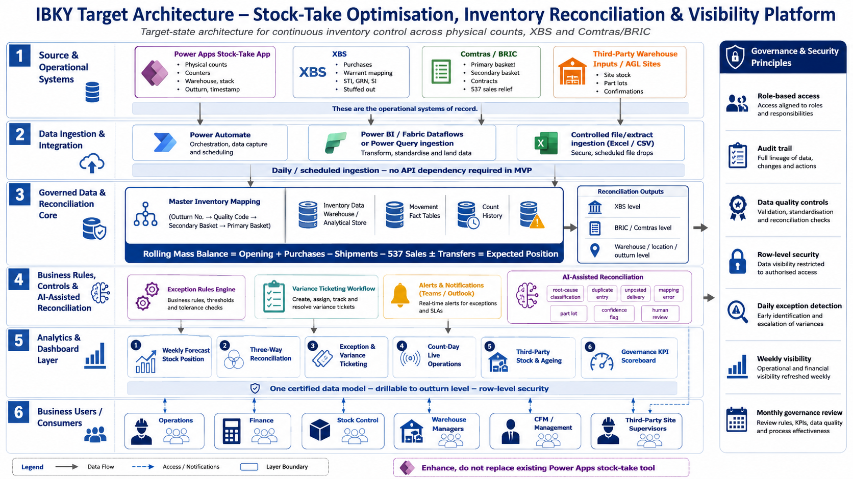

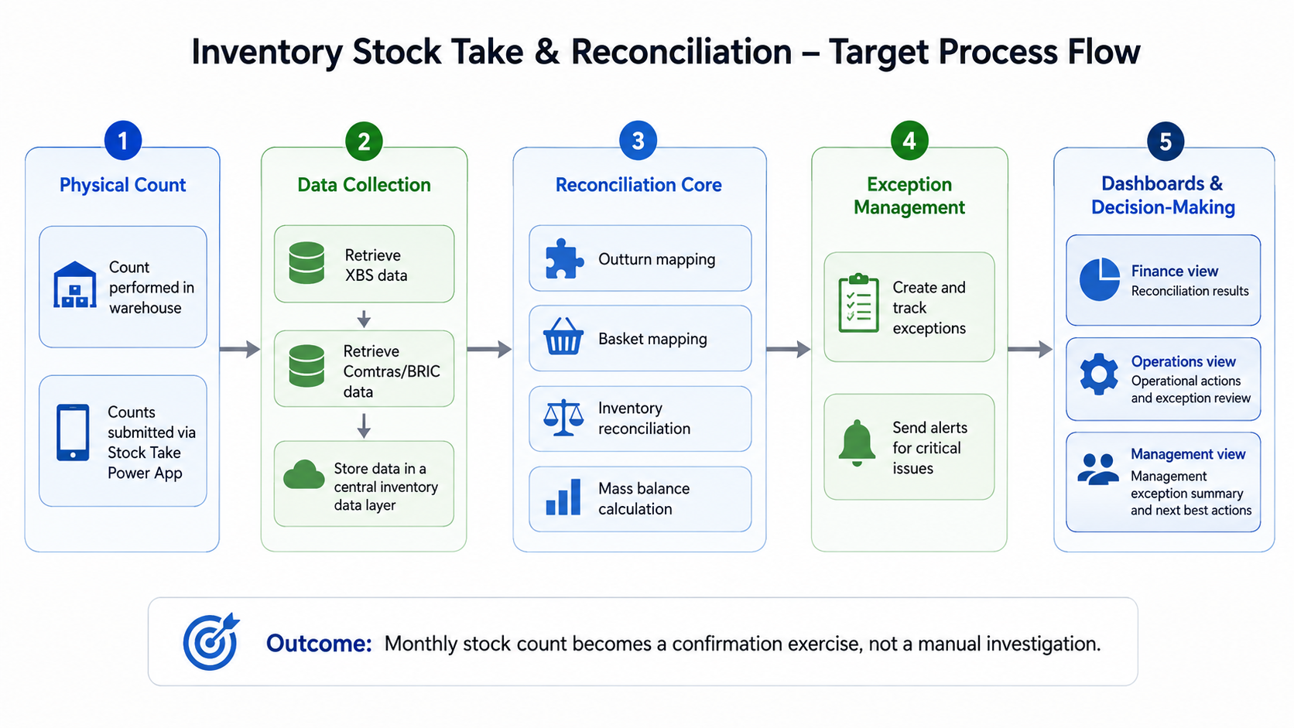

6. Stakeholders & Responsibilities (RACI)
List internal and external individuals to be involved. Use R = Responsible, A = Accountable, C = Consulted, I = Informed.

6.1 Internal Stakeholders
Name | Role / Title | Department / Entity | Responsibility | RACI
 | Executive Sponsor |  | Funding approval, strategic alignment | A
 | Business Owner / HOD |  | Requirements, prioritisation, UAT sign-off | A
 | Process Owner / SME |  | As-is process, validation, testing | R
 | IT / Systems Lead |  | Technical governance, infrastructure | R
 | Internal Developer(s) |  | Build, unit test, deployment | R
 | Data / BI Lead |  | Data mapping, reporting | C
 | Finance / Controlling |  | Business case, cost tracking, benefits realisation | C
 | Internal Audit / Risk |  | Controls review, SoD | C
 | Change / Training Lead |  | Communications, training rollout | R
 | End Users |  | UAT, feedback, adoption | I

6.2 External Stakeholders
Name / Company | Role | Responsibility | RACI
Pathways Technologies | External developer(s) / consultants | Build, testing, documentation | R
Pathways Technologies | Systems integrator | End-to-end interface delivery | R
Microsoft | Cloud / hosting provider | Infrastructure, SLAs | C
 | External auditor | Assurance on controls (if in scope) | I
 | Regulator (if applicable) | Compliance oversight | I

7. Quantified Expected Benefits
Quantify wherever possible. Use conservative assumptions and cite the baseline used.

7.1 Financial Benefits
Benefit Category | Baseline (Today) | Post-Implementation | Annual Value (USD) | Assumption / Source
Full Time Equivalent time saved (hrs/week × rate × 52)
Overtime reduction
Error / rework cost avoidance
Interest / working-capital saving (faster processing)
Penalty / fine avoidance (compliance)
Licence / vendor cost reduction
Revenue uplift (if applicable)
TOTAL ANNUAL FINANCIAL BENEFIT

7.2 Non-Financial / Qualitative Benefits
Benefit | Measure / KPI | Baseline | Target
Cycle time reduction | hours / days
Error rate reduction | % or #
Improved data quality / auditability
Reduced key-person dependency
Improved employee experience
Improved customer / supplier experience
Enhanced controls / risk reduction

7.3 Payback & ROI
Total investment (one-off, USD)
Recurring annual cost (USD)
Total annual benefit (USD)
Net annual benefit (USD)
Payback period (months)
3-year ROI (%)

8. Cost & Resources (High Level)
You are not expected to produce a detailed financial model. Give your best estimate. Controlling & Shared Services will help refine this during review.

What do you think this will require?
- [Systems / software / licensing e.g. a new tool, or a change to an existing system]
- [Training or change management for affected staff]
- [People / time e.g. IT support, your team's time to test and roll out]
- [Anything else you expect will be needed]

9. Timeline & Urgency
Question | Response
When would you like this resolved?
Is there a deadline driving this? (e.g. audit, regulatory, year-end)
Any known constraints on timing?
Target Go-Live date

10. Risks & Assumptions
# | Risk / Assumption | Impact (H/M/L) | Likelihood (H/M/L) | Mitigation | Owner
1 | Timely access to source data from Power Apps, XBS and Comtras/BRIC is required for reconciliation design, dataflows, dashboards and testing. | H | M | Confirm data owners and access requirements during discovery; agree extract formats early; use controlled Excel/CSV extracts where direct connectivity is not available; escalate delays through project governance. | IBKY IT / Data Owners
2 | Data quality issues such as unmapped outturns, missing quality codes, unposted GRNs, duplicate entries or inconsistent basket mappings may affect reconciliation accuracy. | H | H | Establish master inventory mapping rules; create exception logs; validate mapping with Finance and Operations; use sample historical data for reconciliation testing before go-live. | IBKY Finance / Operations, supported by Pathways Data Team
3 | The 8-week implementation timeline assumes active participation from IBKY users for workshops, validation, SIT, UAT and sign-off. | H | M | Confirm stakeholder availability upfront; nominate business owners and UAT leads; schedule weekly reviews; agree deemed acceptance or escalation process for delayed feedback. | IBKY Project Sponsor / Project Manager
4 | The current scope excludes API integrations, vendor-side development, software licences, cloud costs; any additional scope may affect cost and timeline. | M | M | Clearly document exclusions in the proposal and SOW; manage additional requirements through change control. | Pathways PMO / IBKY Project Manager
5 | Copilot Studio developer account, licensing or environment approvals are delayed. | H | M | Engage HQ technology team during discovery; confirm licensing and environment requirements early; document fallback MVP approach if agent setup is delayed. | IBKY HQ Tech / IBKY IT
 | AI agent outputs may be misunderstood as final reconciliation decisions. | H | M | Clearly define agent as advisory only; enforce human review and approval; include disclaimer and workflow controls in the agent design. | Pathways / IBKY Stock Control
 | Escalation workflow cannot be configured accurately without a clear departmental hierarchy and SLA rules. | M | M | IBKY to provide exception ownership matrix, escalation hierarchy and SLA thresholds during design. | IBKY Operations / Finance
 | XBS APIs are not available during rollout. | M | H | Use controlled XBS extracts and upload templates for MVP; design architecture to support future API integration when available. | IBKY IT / Pathways Data Team
 | Digital reconciliation sign-off adoption is low if users continue manual approval outside the system. | H | M | Configure sign-off workflow with audit trail; train users; align SOP and governance review to the digital workflow; track sign-off performance as KPI. | IBKY Management / Stock Control

11. Approvals & Sign-Off
This business case requires the following signatures before proceeding to build. Each signatory confirms they have reviewed the case and endorse the proposed approach, costs and benefits.
Role |  | Name | Signature | Date
HOD (Preparer)
Line Manager
Head of Shared Services
Regional CFO

Sign-off notes
- HOD (Preparer) - confirms accuracy of problem statement, as-is process, benefits and costs.
- Line Manager - endorses business need and departmental priority.
- Head of Shared Services - confirms alignment with shared-services roadmap, standards and delivery capacity.
- Regional CFO - final financial approval, funding release and benefits-realisation ownership.

12. Submission & Next Steps
Once complete, send this document to Controlling & Shared Services for review. You will be contacted to discuss further scoping, clarify any details, and agree next steps.
Field | Response
Submitted by
Date
Reviewed by (Controlling & Shared Services)
Review outcome / next steps

